Group 19

Design Specification

Austen Stone, Reshma Thomas, Arian Tirado

Glossary

CRC Cards 2

Class Diagram 5

Sequence Diagram 6

State Diagrams 7

# CRC Cards

|  |  |
| --- | --- |
| Account | |
| Log in actor | Seller  Customer |

|  |  |
| --- | --- |
| Seller | |
| Seller can update the inventory by adding products, invoice price, sell price and update the available quantity |  |

|  |  |
| --- | --- |
| Customer | |
| Customers can browse, manage ShoppingCart, and Checkout. |  |

|  |  |
| --- | --- |
| Inventory | |
| Holds available products and their UPC codes | Product |

|  |  |
| --- | --- |
| Product | |
| Holds name, UPC, price, stock | ProductInfo |

|  |  |
| --- | --- |
| ProductInfo | |
| Full product description, pricing and availability (quantity available) in a pop-up window | MainWindow |

|  |  |
| --- | --- |
| MainWindow | |
| Displays all information and calculates transaction. Also displays list of products. | Product  Inventory  Scanner  Customer |

|  |  |
| --- | --- |
| ShoppingCart | |
| Holds items that are being purchased | MainWindow  Product |

|  |  |
| --- | --- |
| Input | |
| Manages input of customer | MainWindow  ShoppingCart |

|  |  |
| --- | --- |
| Checkout | |
| Checkout window with each product with its count. | ShoppingCart |

|  |  |
| --- | --- |
| Finance | |
| Keeps track of costs, revenues, and profits. | MainWindow  Product |

|  |  |
| --- | --- |
| Business | |
| Holds general information about the business. | MainWindow |

# Class Diagram

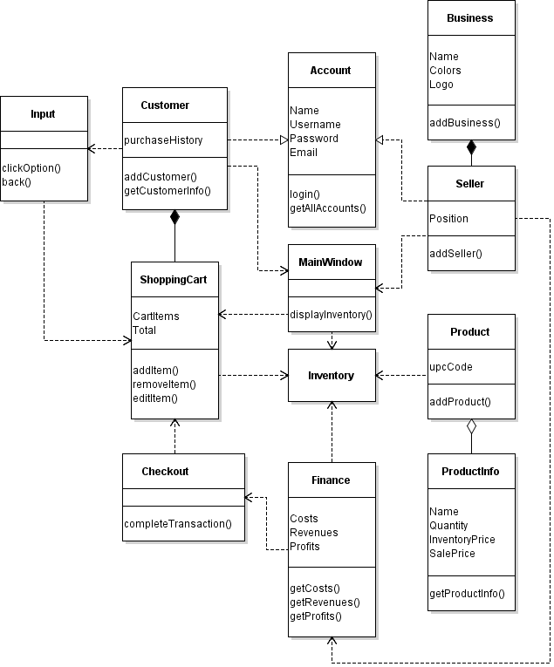

# Sequence Diagram

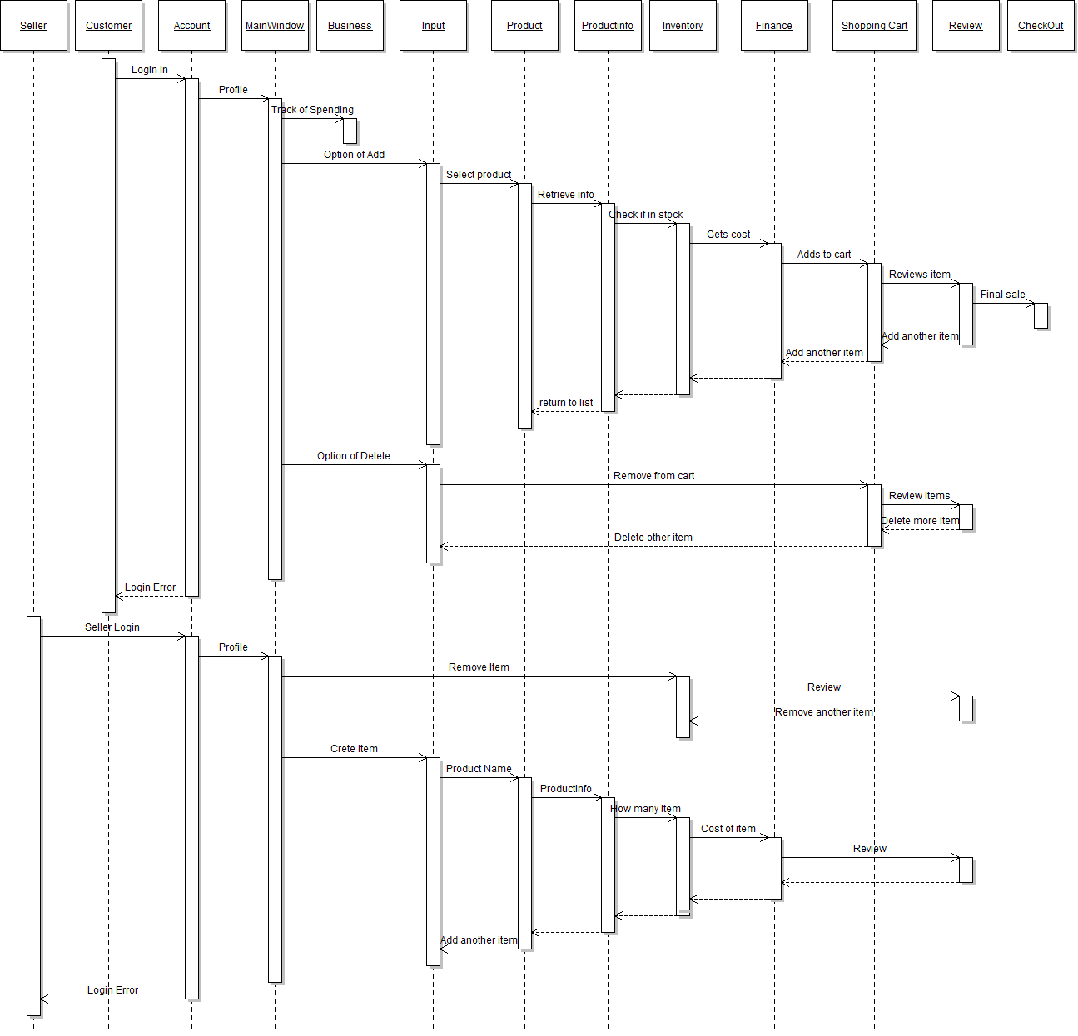

# State Diagrams

